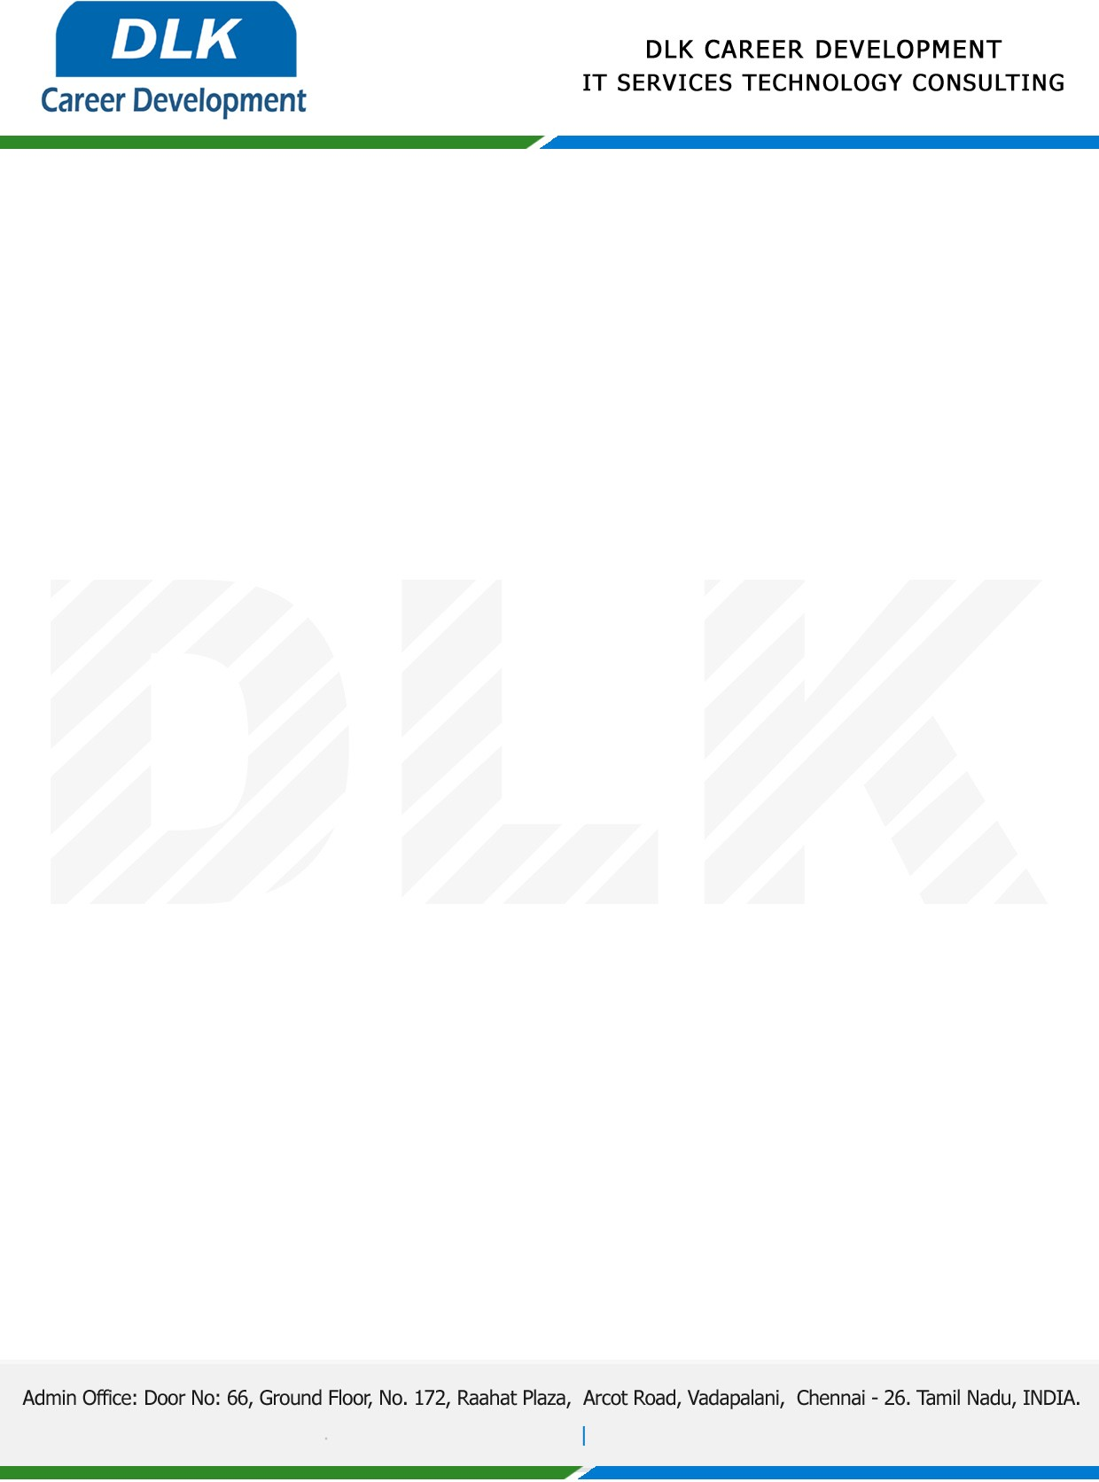

**Date: 24/April/ 2023**

**COURSE COMPLETION CERTIFICATE**

**Name:** MR JAISHIVASH V

**Reference Number:** 605346075616

**College Name**:Avichi College of Arts & Science,Chennai.

**Degree & Department:** BCA-Computer Application

**Batch ID:** 2021 – 2024

**Program language:** Java with Data Structures

*{Java: Basic of Java, OOPS, Array, Control Statement, Exception Handling, Multithread*

*Data Structure: Linked List, Stack, Queue, Graph, Tree, Sorting}*

**Duration:** September 2022and November 2022 **(3 Months)**

**MR JAISHIVASH V ,** displayed professional traits during the Course period and managed to complete all assigned tasks as required. He was Hardworking, dedicated and committed it was a pleasure with us in this short period.

**We** **Wish all the best for your future.**

For **DLK CAREER DEVELOPMENT**

**HR Manager**

**VELMURUGAN J**